**LAB 05 TASKS OUTPUTS**

**BY: SYED MUHAMMAD ALI NAQVI**

**ROLL NO: 25K-3039**

**TASK 1:**

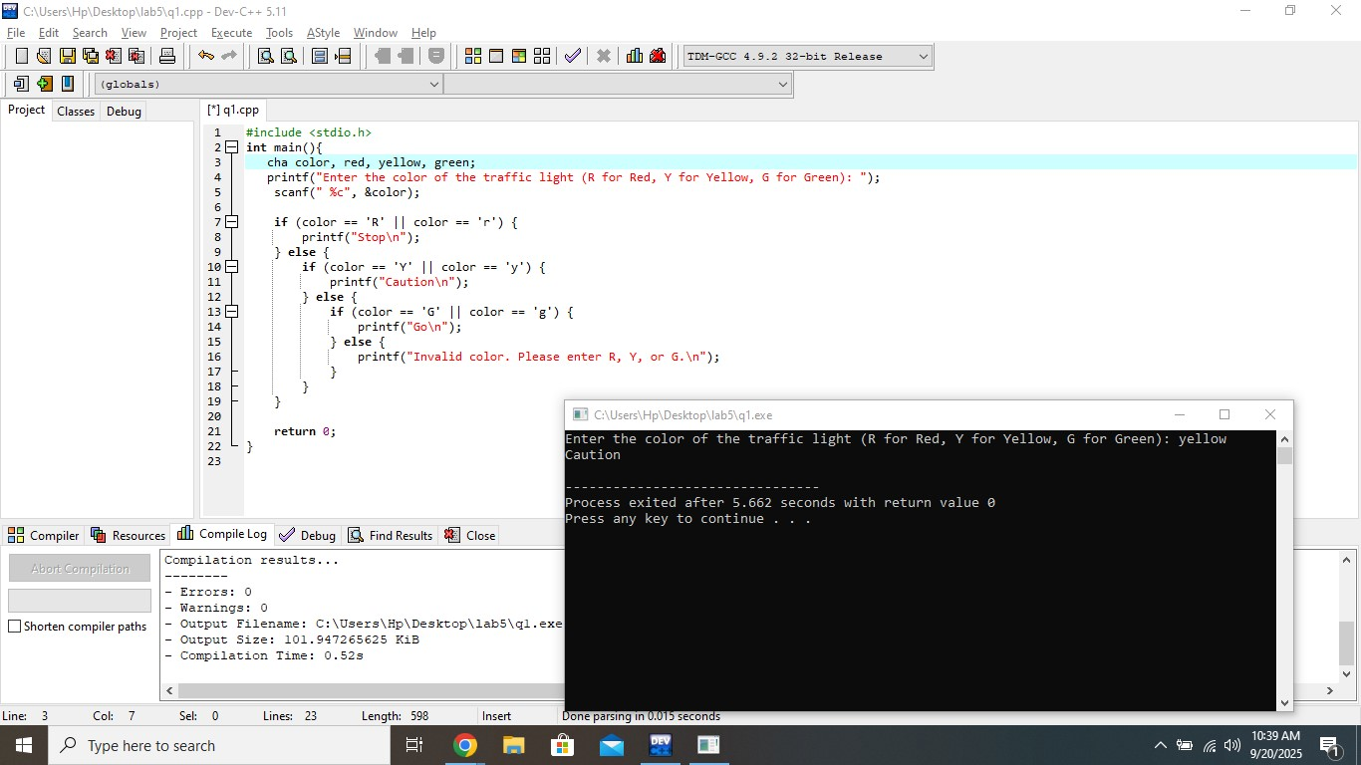

**TASK 2:**

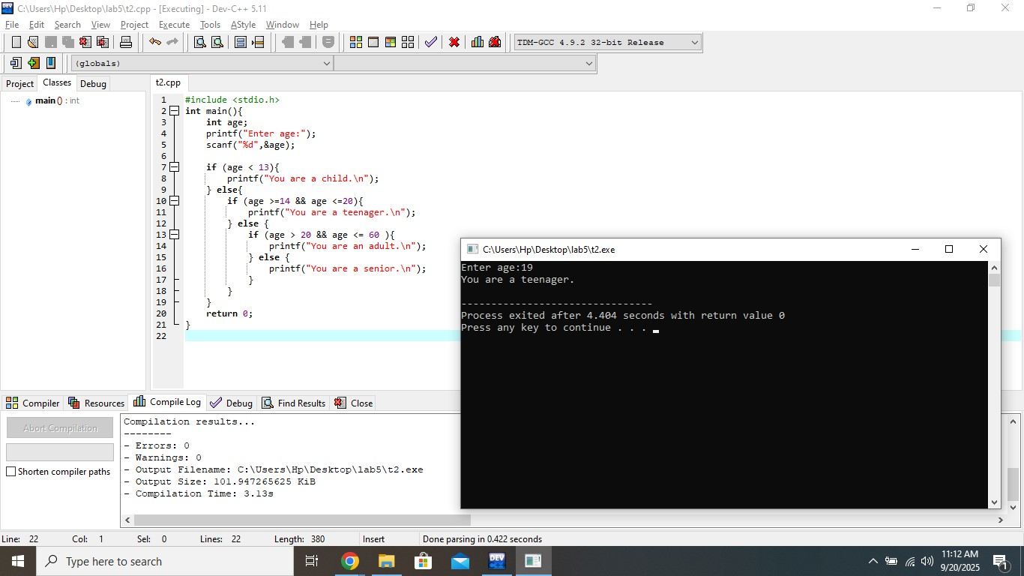

**TASK 3:**

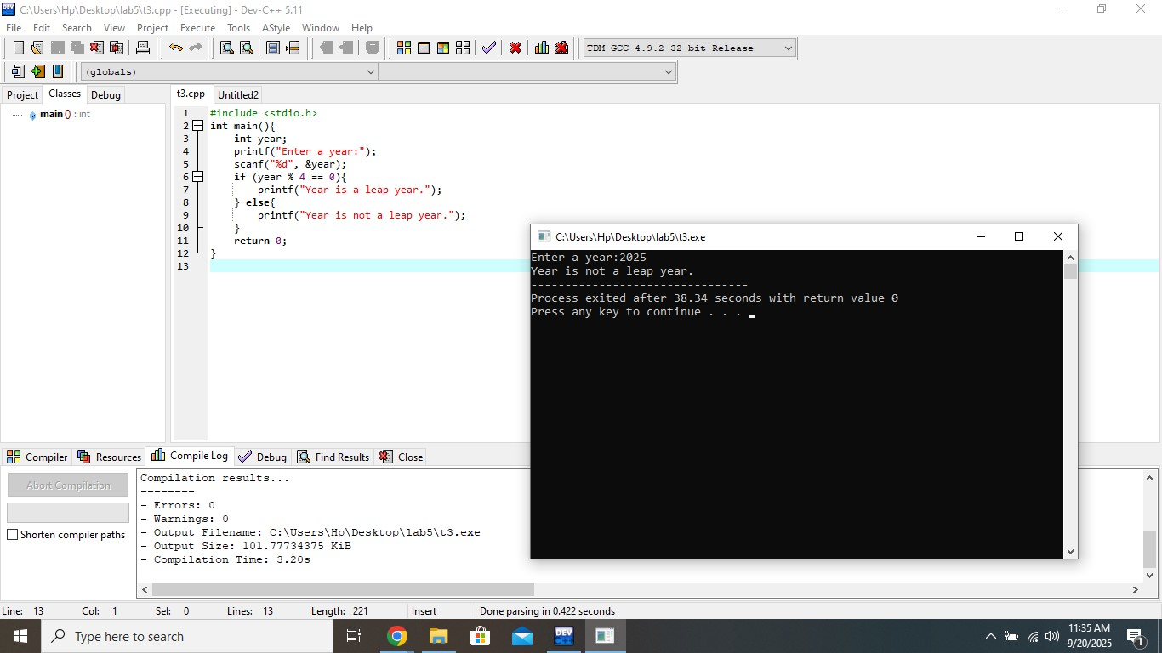

**TASK 4:**

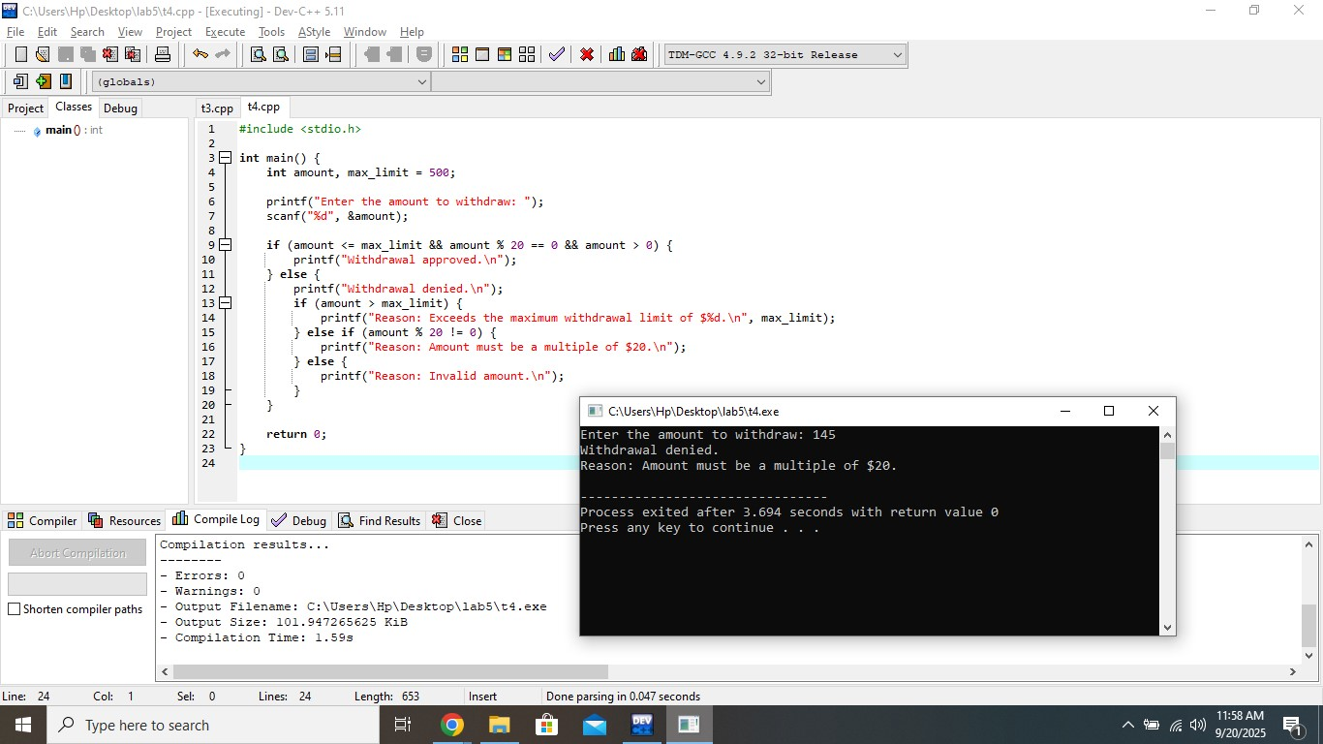

**TASK 5:**

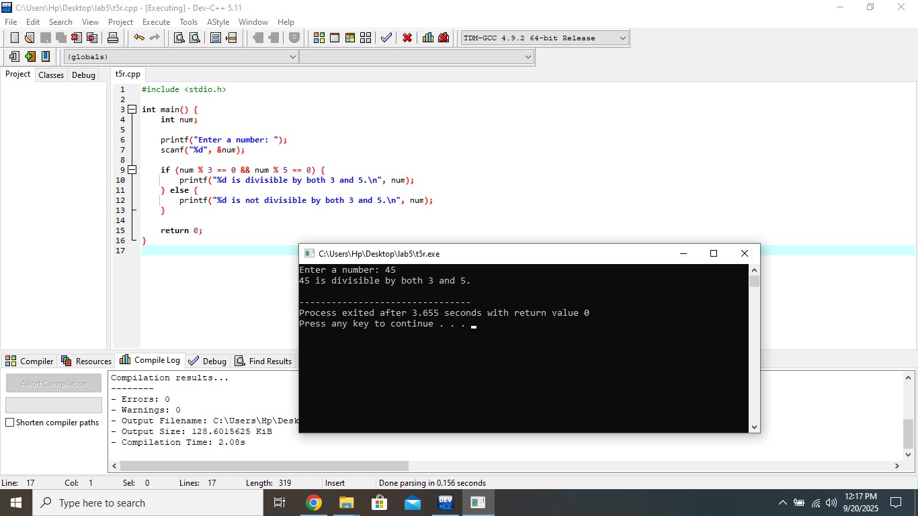

**TASK 6:**

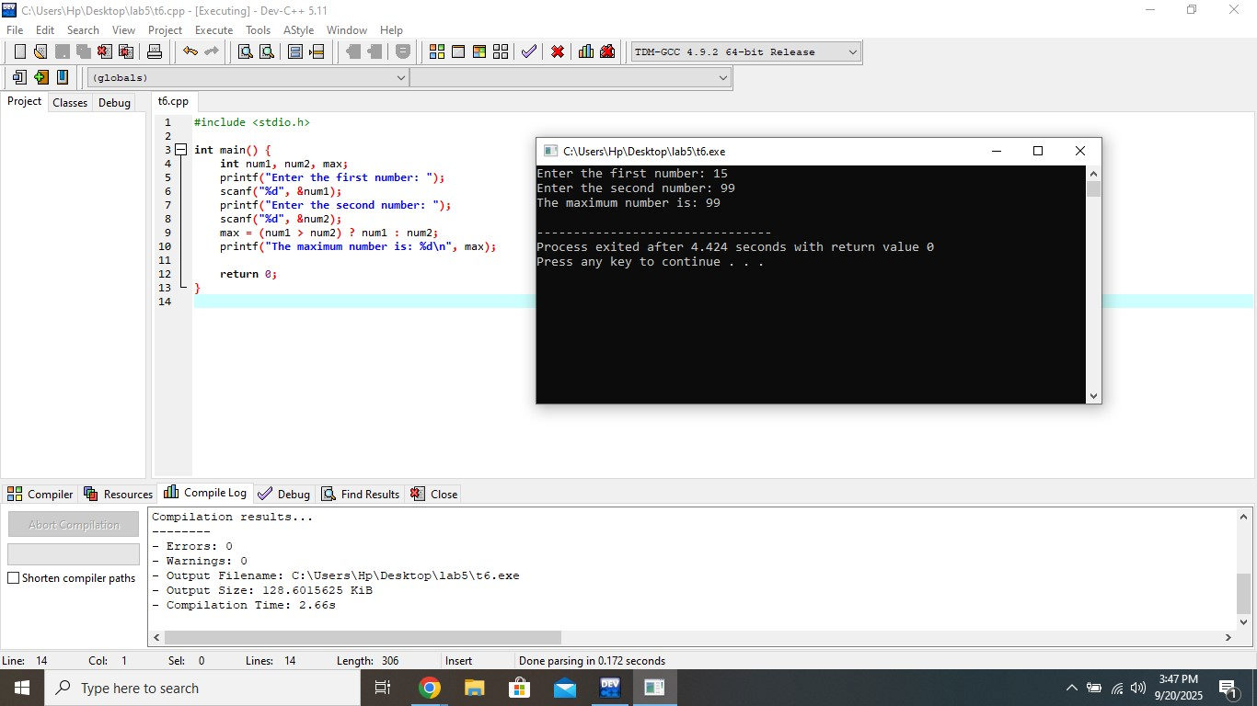

**TASK 7:**

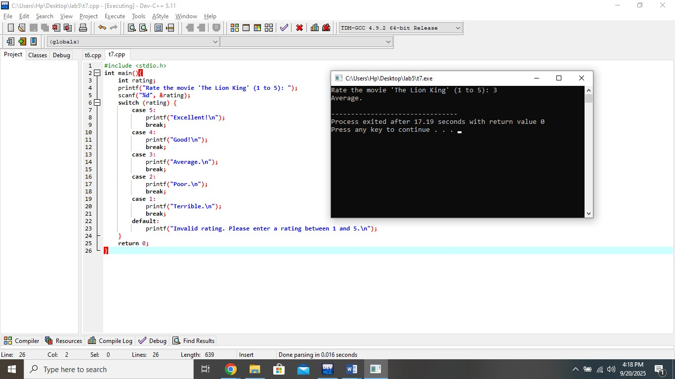

**I HAVE CHANGED THE FILE NAMES OF C++ TO PROPER BEFORE UPLOADING ON GITHUB.**